Mobeen Aftab

Scotia airline testing document

|  |  |  |  |  |  |
| --- | --- | --- | --- | --- | --- |
| **Test number** | **Test case** | **input** | **Expected output** | **Actual output/pass** | **screenshot** |
|  | Log in test pass | Correct Admin username and password | Into main menu screen | Pass | M:\Projects\Software Development\C#\ScotiaAirline\screens\t1.PNG |
|  | Log in test fail | Wrong Admin username and password | Message box displaying error | pass | M:\Projects\Software Development\C#\ScotiaAirline\screens\t2.PNG |
|  | Enter flight class | Button click for flight | Flight class menu | Pass | M:\Projects\Software Development\C#\ScotiaAirline\screens\5.PNG |
|  | Enter passenger class | Button click for passenger | Passenger class menu | Pass | M:\Projects\Software Development\C#\ScotiaAirline\screens\3.PNG |
|  | Enter seat class | Button click for seat | Seat class menu | Pass | M:\Projects\Software Development\C#\ScotiaAirline\screens\4.PNG |
|  | Add flight “scotia” available for booking | New flight and status | New flight with status in database | Pass | M:\Projects\Software Development\C#\ScotiaAirline\screens\t6.PNG |
|  | Add flight GLA checking in | New flight GLA with Check in status | New flight in database | pass | M:\Projects\Software Development\C#\ScotiaAirline\screens\t7.PNG |
|  | Change GLA flight to closed | Closed status | Flight is now closed | pass | M:\Projects\Software Development\C#\ScotiaAirline\screens\t8.PNG |
|  | Load all seats grouped by flights | Load button with sql query retrieving database entries | Seats, seat plan and flight assigned to seats | pass | M:\Projects\Software Development\C#\ScotiaAirline\screens\t9.PNG |
|  | Add new seat to flight | Add new free seat for flights, seated = 16 seat plan = 1F status =free | New seat id with seat plan assigned to flight | pass | M:\Projects\Software Development\C#\ScotiaAirline\screens\t10.PNG |
|  | Edit seat ID 16 to seat plan 3D and reserved status | edit seat id 16 to seat plan 3F with reservation | Edited seat plan on id 16, reserved | pass | M:\Projects\Software Development\C#\ScotiaAirline\screens\t11.PNG |
|  | Count total number of free seats | Available free seats on flight button count | Total number of free seats (currently 4) | pass | M:\Projects\Software Development\C#\ScotiaAirline\screens\t12.PNG |
|  | Total money made from flight | Sum of cash per flight takings | Total number of cash sum of all combined seat costs per flight | pass | M:\Projects\Software Development\C#\ScotiaAirline\screens\totalprice.PNG |
|  | Count total number of reserved seats | All reserved seats on flight count | Total number of reserved seats | pass | M:\Projects\Software Development\C#\ScotiaAirline\screens\t13.PNG |
|  | Count total number of booked seats | All booked seats counted | Total number of seats booked | pass | M:\Projects\Software Development\C#\ScotiaAirline\screens\t14.PNG |
|  | Add normal passenger to flight scotia | ID=10, type =normal, price 100, pass name = dan, flight id =scotia, | New passenger with seat on flight scotia | pass | M:\Projects\Software Development\C#\ScotiaAirline\screens\t15.PNG |
|  | Add business passenger to scotia flight | ID=9, type =business, price 75, pass name = john, company = 42studios | New business passenger on flight scotia with company name and discount | pass | M:\Projects\Software Development\C#\ScotiaAirline\screens\t.16.PNG |
|  | Add islander passenger | ID=11, type =islander, price 90, pass name = snake, address = long island | New islander passenger with islander address and discount | pass | M:\Projects\Software Development\C#\ScotiaAirline\screens\t17.PNG |
|  | Edit passenger id 8 and change flight | ID=8, type =islander, price 90, pass name = Steven, address = the island | Edit old passenger and change flight to scotia | pass | M:\Projects\Software Development\C#\ScotiaAirline\screens\t18.PNG |
|  | Add passenger to GLA closed flight to test error handling | Any passenger to closed flight GLA | Flight database should prompt error message |  | M:\Projects\Software Development\C#\ScotiaAirline\screens\t19.PNG |

Before database testing screen shots:

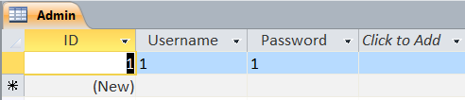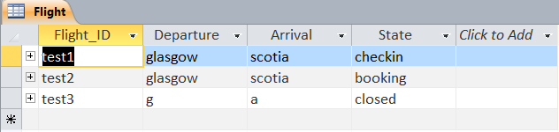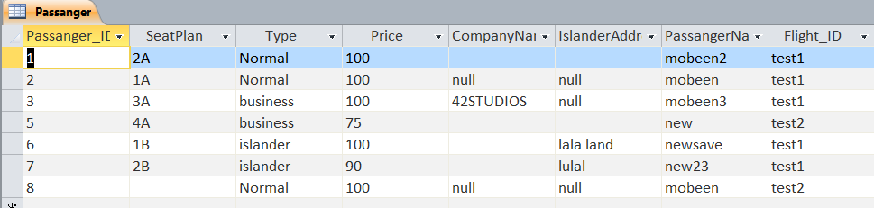

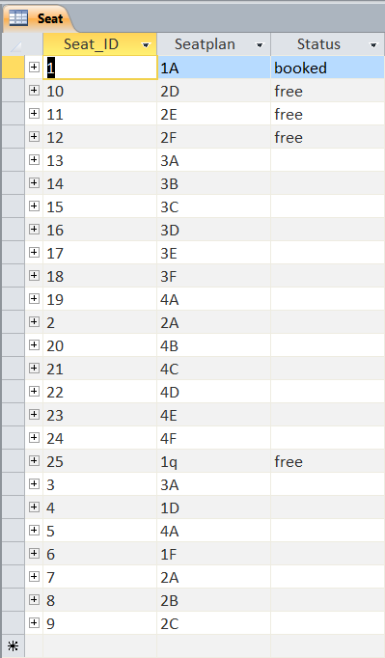

After database testing screen shots:

